Gender Differences In Interest in Using Electronic Money: An Application of Theory
Planned Behavior

Naili Farida
Faculty of Social and Political Sciences, Business Administration
Diponegoro University, Semarang
faridanaili@ymail.com
Elia Ardyan
Management Undergraduate Study Program, STIE Surakarta
ardyan.sbs@gmail.com
Nuryakin
Master of Management Department, Universitas Muhammadiyah Yogyakarta
nuryakin @umy.ac.id

ABSTRACT
The objective of this research is to develop a behavior model with Theory of Planned Behavior (TPB) in order to give effect to the customer in the transaction payment with the use of electronic money and gender differences in the transaction payment with the use of electronic money. The analysis in this research used the analysis of Structural Equation Modeling (SEM). Amos version 20 was used in data processing. The findings of this research show the differences between male and female respondents. The findings show that: (1) attitudes positively and significantly affect the interest in the use of electronic money (for male and female respondents), (2) for male, subjective norms have a positive and significant effect on the interest in using electronic money; for female, subjective norms have a positive but not significant effect on the interest in using electronic money, and (3) perceived control behavior has not been able to significantly increase the interest in using electronic money (particularly for male respondents).

Key words: Theory of planned behavior, electronic money, gender, and Syariah Bank

INTRODUCTION
Electronic money is a payment instrument that is increasingly in use, either in Indonesia or in other countries. The countries developing electronic money, among others, are , Swedia , Turki , Singapura, Hongkong, Malaysia , and others. These countries have started to decrease the use of cash and increase the use of electronic money in the form in accordance with the rules of the respective countries.
In line with the increasingly high development of information technology era in banking world, it is necessary for bank institutions to focus on the consumer’s needs. One of the main factors to attract consumers is through information technology, that is, speed service for banking customers. However, Syariah banks are not yet as sophisticated as conventional banks. Syariah banks are required to continue to grow because the increasingly diverse needs of customers; non cash payments are needed not only to facilitate customers, but also due to safety reason, since its use if cashless (Jawa Pos, November 27, 2015).
Bank of Indonesia (BI) boosts the growth of electronic money use by relying on the program of Non Cash National Movement. This is done considering the low use of electronic money. The current growth of domestic electronic transactions has not been followed by the use of electronic money. According to the Head of BI Transaction System Monitoring and Policy Department, the use of electronic money on non cash transactions has only reached 1%. Although the growth of electronic money has reached 71.7% per September 2015, BI as the transaction system regulator will keep pushing the non cash movement, particularly electronic money (Hafid Fuad, 2015, BI Boosts the Growth of Electronic Money, www.sindonews.com ).
Based on the mapping conducted by Bank of Indonesia, users of electronic money has expanded to the middle and lower levels of society; the growth of transaction increased as much as 29% in 2014, and so did the volume and amount of transaction. In 2014, the amount of the use of electronic money transactions was only as big as 1.8% compared to Gross Domestic Product; later in 2015, Bank of Indonesia will seek to encourage the use of electronic money transactions to increase to 2.4% compared to Gross Domestic Product.
This research is different from previous research conducted by . Moreover, the study explains a risks on electronic money. These risks include operational, fraud, and legal risks. show differences in the legal aspect on electronic money use in the United States of America, European Union, and Turkey. asserts in Japan shows that currency demand function depends on the adoption of electronic money; this finding concludes that people use electronic money because they have more savings. Indonesia is a developing country, which is different from developed countries in terms of the use of electronic money. The cultural aspect of people’s belief in the use of cash is higher than that of electronic money. Consumers have to be encouraged to use electronic money, because it does not only benefit the government, in this case Bank of Indonesia as the regulator will be able to save money-making cash; but also the consumers, since the use of electronic money is safer and more effective with a much smaller risk compared with the use of cash.
The problem of this research is the low number of customers, particularly the customers of Syariah banks, in transaction payments using electronic money. The objective of this research is to develop a behavior model with TPB in order to give effect to the customer in the transaction payment with the use of electronic money and gender differences in the transaction payment with the use of electronic money.

LITERATURE REVIEW
Electronic money
explain that the electronic money phenomenon was firstly investigated by the European Central Bank in 1993 and the report was published in 1994. There are previous studies stating that several countries have applied it before 1990s . In the development of banking world, electronic money is a product with an increasing utilization. Several studies have started to discuss electronic money . In Indonesia, banking authority gives support to the society in using electronic money as a way to do transactions.
There are several definitions explaining electronic money. Bank of Indonesia Regulation No. 11/12/PBI/2009 states the definition of electronic money as a payment instrument that meets these elements: (1) issued on the basis of the value for money submitted in advance by the holder to the issuer, (2) the value for money is saved electronically in a media like a server or a chip, (3) used as a payment instrument to the trader that is not the issuer of the electronic money, and (4) the value for money paid by the holder and managed by the issuers is not a deposit as defined in the laws regulation banking. states that electronic money includes all non cash and paperless payment instrument, like plastic cards and direct transfer, and all money transactions through electronic lines such as ATM, Electronic Funds Transfer at Point of Sale (EFTPOS), telephone, fax, and internet.
There are two types of electronic money : online electronic money and offline electronic money. Online electronic money means something is needed to interact with the bank (through modem or line) in order to do a transaction with the third party. Offline electronic money means transactions with no direct involvement with the bank. In Indonesia, electronic money is divided into two types, namely chip based and server based. Chip based is a type of electronic money issued by Bank of Indonesia; for example, Flazz (BCA), electronic money, e-toolcard (Mandiri), Brizzi (BRI), Mega cash (Mega Bank), and several other banks. Server based is a type of electronic money in which its making can be done by the company; for example, Dompetku (Indosat), Finpay (Finnet), Doku (Nusa Inti Arta), XL Tunai (XL), and other companies.

Theory of Planned Behavior (TPB)
Theory of Planned Behavior is a theory developed from Theory of Reasoned Action (TRA) by using the basic assumption that human beings are creatures with the power of reason to decide what behavior will be taken in a conscious way and to consider all available information. Furthermore, develops TRA by adding a construct, namely perceived behavioral control variable, that will affect interest and behavior.
Various studies have tried to apply the Theory of Planned Behavior on banking sector. Such studies include the application of TPB on internet banking , and on micro credit . Research on the Theory of Planned Behavior by Greenslade (2005) finds that a person makes a decision for his action with a systematic use of information obtained by him self. This theory states that the intention of a person is influenced by three independent elements, including attitudes (positive and negative evaluation in doing something), subjective norms (pressure or expectation to do something or not), and perceived social behaviors. Perceived behavioral control (PBC) is a perceived ease or difficulty in behaving . Furthermore, someone’s attitudes are shaped by the person’s greatest owned beliefs, whereas subjective norms are established through normative beliefs that represent the perception of the closest people on involvement preferences of a person in a particular behavior. PBC is influenced by beliefs about whether someone has access to the necessary resources including time and skills to perform a particular behavior (Corner & Armitage, 2006). TPB defines individual intention as a function of the three components of attitudes, subjective norms, and PBC .

HYPOTHESIS
The Effect of Subjective Norms on the Interest in Using Electronic Money
Subjective norms are also based on prominent beliefs, the so-called normative beliefs, whether respondents’ special thinking reference state they should or should not do a certain action . These subjective norms are also called normative beliefs .. The subjective norms are basically a social impact made by someone who has the closest relationship (family, friends, colleagues, etc.) that may have an influence in decision making. Theoretically, the subjective norms affect the interest of performing a certain action . In this study, the behavior interest was shown by the interest in using electronic money. Colleagues, friends, or family could influence someone’s interest in using electronic money. Based on this explanation, this study proposed hypothesis 1, that is:
H1: Subjective norms would be able to increase the interest in using electronic money.

The Effect of Attitudes on the Interest in Using Electronic Money
Attitudes are basically a key concept in explaining interest in human behavior . see attitudes as one’s performance in behavior compared to general performance. Attitudes are defined as a general point of view on a thorough evaluation of a person about an object, person or location, and have a fundamental influence on intention and behavior . A positive evaluation on electronic money will surely be able to increase someone’s interest in using electronic money. Based on this explanation, this study proposed hypothesis 2, that is:
H2: Attitudes would be able to increase the interest in using electronic money.

The Effect of Perceived Behavior Control on the Interest in Using Electronic Money
Perceived Behavior Control is a factor referring to the perceived ease or difficulty in performing certain behaviors and assuming experiences in anticipating obstacles . The easier the use of electronic money, the more people will have interest in using it. They will use electronic money to do various transactions that are facilitated by electronic money. Based on this explanation, this study proposed hypothesis 3, that is:
H3: Perceived Behavior Control would be able to increase the interest in using electronic money.

METHOD
Samples and Sampling Techniques
This research used a survey method and the population was all customers of Syariah Bank in Semarang City. The respondents were as many as 300 people, consisting of 150 male and 150 female, drawn in Semarang City from Syariah Bank customers with a purposive sampling technique and an accidental sampling technique. The measurement scale used was Likert scale with these criteria: 1) active customers of Syariah Bank, 2) customers who did not yet use electronic money payment, 3) minimum age of 17 years old, and 4) residents of Semarang City. The analysis technique used was Structural Equation Modelling. In processing the data, the study used Amos software version 20.

RESULTS
Reliability and Validity
In this study, the test of validity used loading factor and AVE, whereas the reliability test used composite reliability. The requirement for loading factor and AVE was no less than 0.5, whereas the requirement for composite reliability was that the value should be above 0.6. Table 1 below shows that all instruments for both female and male samples can already be declared valid and reliable because the values are above the requirements.
Tabel 1. Factor Loading, Composite Reliability (CR) and Average Variance (AVE)
INDIKATOR | FEMALE |  |  | MALE
INDIKATOR | FACTOR LOADING | CR | AVE | FACTOR LOADING | CR | AVE
ATTITUDE |  | 0,962 | 0,807 |  | 0,961 | 0,807
VA1 | 0,925 |  |  | 0,921
VA2 | 0,952 |  |  | 0,937
VA3 | 0,941 |  |  | 0,941
VA4 | 0,937 |  |  | 0,92
VA5 | 0,817 |  |  | 0,851
VA6 | 0,806 |  |  | 0,811
SUBJECTIVE NORM |  | 0,948 | 0,902 |  | 0,956 | 0,916
VSN3 | 0,95 |  |  | 0,957
VSN2 | 0,949 |  |  | 0,957
PERCEIVED BEHAVIOR |  | 0,949 | 0,863 |  | 0,96 | 0,888
VPV3 | 0,866 |  |  | 0,92
VPV2 | 0,967 |  |  | 0,964
VPV1 | 0,95 |  |  | 0,942
INTEREST |  | 0,942 | 0,843 |  | 0,959 | 0,888
VITU1 | 0,926 |  |  | 0,922
VITU2 | 0,882 |  |  | 0,960
VITU3 | 0,946 |  |  | 0,944

Fit model is a fit between the created model and the research data. In this study, the fit model used NFI, RFI, IFI, TLI, and CFI. For the male respondents, the results of the fit model are NFI (0.903), RFI (0.876), IFI (0.925), TLI (0.903), and CFI (0.924). These results are in accordance with the determined cut off value of 0.90 and above. Although the value of RFI is below 0.90, it can still be tolerated because this value is considered as average. For the female respondents, the results of the fit model are NFI (0.888), RFI (0.857), IFI (0.911), TLI (0.855), and CFI (0.910). These fit model results are still in the average level and acceptable.

Hypothesis Tests
There are three hypothesis proposed in this study. These three hypothesis were tested based on the sample gender (male and female) and analyzed their differences.
Male samples. Hypothesis 1 in the study states that subjective norms would be able to increase the interest in using electronic money. The result of hypothesis testing concludes that subjective norms were able to increase the interest in using electronic money (ß =0.131; p=0.049). Thus, hypothesis 1 is accepted. Hypothesis 2 states that attitudes towards electronic money would be able to increase the interest in using electronic money. The result shows that attitudes towards electronic money were able to increase the interest in using electronic money (ß =0.778; p<0.05). Thus, hypothesis 2 is accepted. Hypothesis 3 in this study is perceived behavior would be able to increase the interest in using electronic money. The result of hypothesis testing concludes that perceived behavior was not able to increase the interest in using electronic money (ß =0.074; p=0.721). Thus, hypothesis 3 is rejected.
Female samples. Hypothesis 1 in the study states that subjective norms would be able to increase the interest in using electronic money. The result of hypothesis testing concludes that subjective norms were not able to increase the interest in using electronic money (ß =0.031; p=0.684). Thus, hypothesis 1 is rejected. Hypothesis 2 states that attitudes towards electronic money would be able to increase the interest in using electronic money. The result shows that attitudes towards electronic money were able to increase the interest in using electronic money (ß =0.750; p<0.05). Thus, hypothesis 2 is accepted. Hypothesis 3 in this study is perceived behavior would be able to increase the interest in using electronic money. The result of hypothesis testing concludes that perceived behavior was able to increase the interest in using electronic money (ß =0.216; p<0.05). Thus, hypothesis 3 is accepted.
Figure 1. The Testing Model of Man Sample

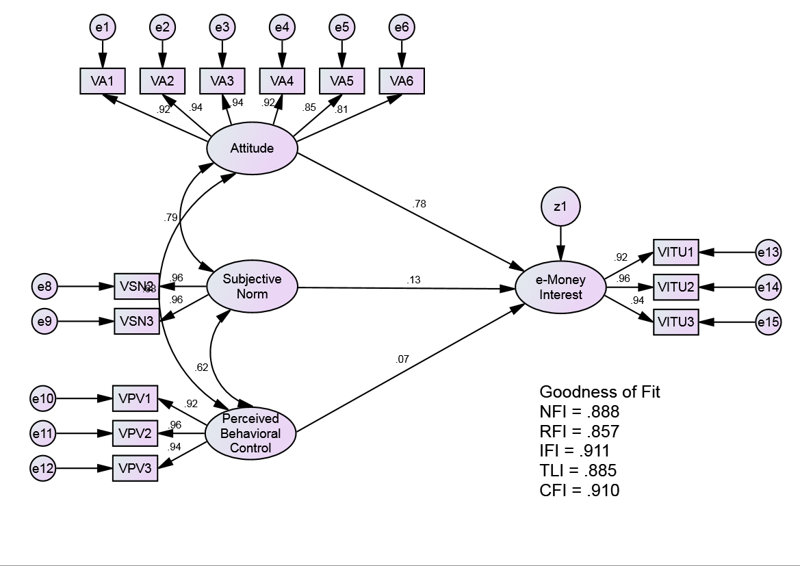

Figure 2. The Testing Model of Women Sample

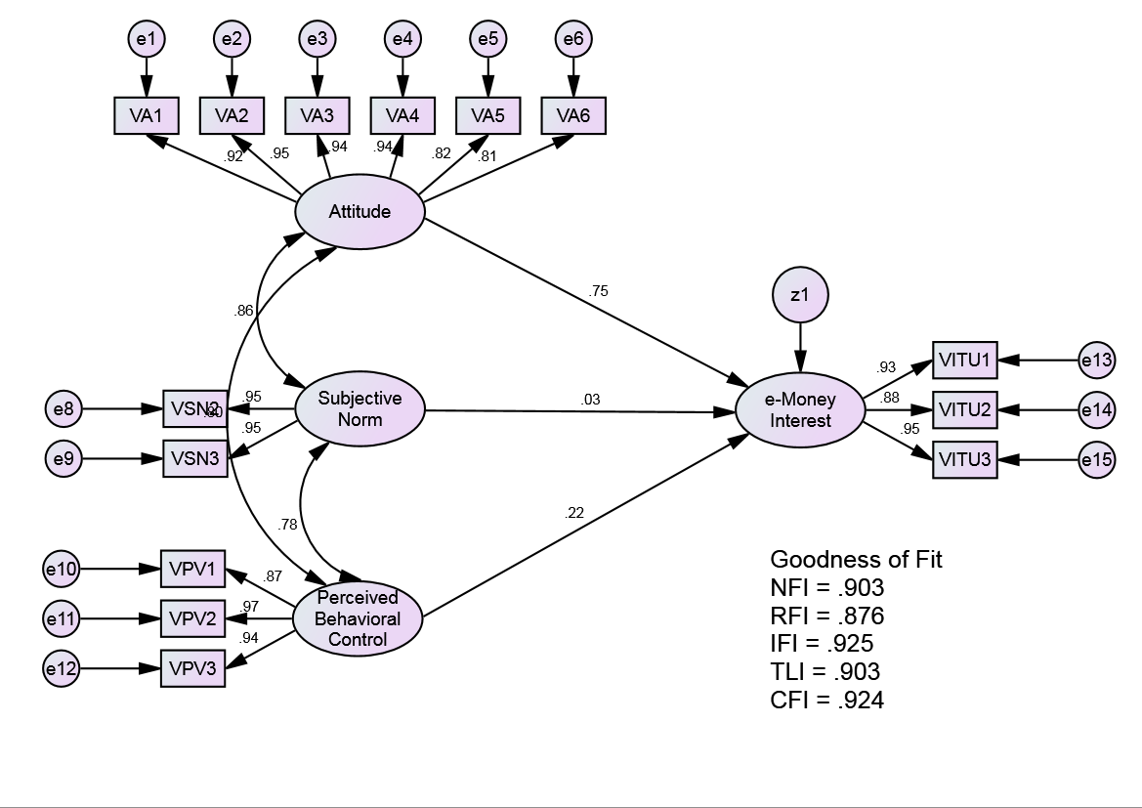

Tabel 2. The Hypotheses Model Testing
HYPOTHESIS |  | Male Samples |  |  | Female Samples
 |  | ß | P | Remarks | ß | p | Remarks
H1 | Subjective norms → Interest in using electronic money | 0.131 | 0.049 | Hypothesis 1 is accepted | 0.031 | 0.684 | Hypothesis 1 is rejected
H2 | Attitudes towards electronic money → Interest in using electronic money | 0.778 | *** | Hypothesis 2 is accepted | 0.750 | *** | Hypothesis 2 is accepted
H3 | Perceived behavior → Interest in using electronic money | 0.074 | 0.172 | Hypothesis 3 is rejected | 0.216 | *** | Hypothesis 3 is accepted

Discussion
Electronic money is a developing phenomenon in Indonesia. A lot of people want something practical, in which they can do transactions of buying and selling without carrying much money. This is a positive attitude on the use of electronic money. The results of this study show that attitudes positively and significantly affect the interest in using electronic money (for both male and female samples). The results of male respondents and female respondents are the same. Attitudes are an evaluation of likes and dislikes or positive and negative on a particular object. Positive attitudes will be able to increase consumers’ interest , and even their buying level . The evaluation given by the consumers on electronic money will very much influence the consumers’ interest in using electronic money.
Subjective norms represent the closest people’s perception on what to be done or not. This study shows differences in the results between male respondents and female respondents. For male respondents, subjective norms have a positive and significant effect on the interest in using electronic money. For female respondents, subjective norms have a positive but not significant effect on the interest in using electronic money. There are several reasons why the results of the effect of subjective norms on the interest in using money are different based on gender: men tend to respond faster to the surrounding environment than women. Men, with their tendency to think logically, will consider whether the opinions of the people in their surroundings are logical to do or not. Women, on the other hand, tend to considerer things emotionally; while the emotional aspect is not formed in a short time.
In general, perceived control behavior is able to significantly increase the behavior interest. However, in this study perceived control behavior was not yet able to significantly increase the interest in using electronic money (particularly the male respondents). This is due to several causes, including men’s tendency in preference of buying things with cash. This happens because the shopping intensity of men is different from that of women; women have the tendency to do more shopping than men. Although men believe that they can use electronic money, their less intensity in shopping makes them think that they do not need electronic money. This is different from women who have very high intensity in shopping. Women will tend to think for a way of not carrying a lot of cash. This leads to a state in which a woman who believes that she is capable of using electronic money will consider to use it.
Theoretical implications of this study are (1) gender strongly influences the application of Theory of Planned Behavior, particularly in the context of interest in using electronic money between male and female; (2) this research, which is a study on the customers of newly developing Syariah Bank, gives a significant impact on the different research results, seen from the side of gender/sex.

Research Limitation and Suggestion
The limitations of this research include: (1) not all indicators of goodness of fit indicate good values, (2) the objects of this research are limited to the customers of Syariah Bank. Further research should include moderating variables or control variables, such as culture, attitude, and buying type. It is then suggested for further research to use a more complex model so that the point of view is not only limited to the use of Theory of Planned Behavior.

REFERENCES

Azjen, I. (1991). The Theory of Planned Behavior. Organization Behavior and Human Decision Process, 50, 179-211.
Azjen, I. (2005). Attitudes, Personality and Behavior (2 ed.). England: Open University Press.
Coats, P. K. (1989). A banker's use of simulation and artificial intelligence for assessing the economics of electronic money networks. European Journal of Operational Research, 41(3), 290-301.
Dehghan, F., & Haghighi, A. (2015). E-money regulation for consumer protection. International Journal of Law and Management, 57(6), 610-620.
East, R. (1993). Investment decision and the theory of planned behavior. Journal of Economic Psychology, 14, 337-375.
Fazio, R. H., & Wulliams, C. J. (1986). Attitude Accessibility as a moderator of the attitude-perception and attitude-behavior relations: An investigation of the 1984 presidential election. Journal of Personality and Social Psychology, 51(3), 505-514.
Fisbein, M., & Azjen, I. (1975). Belief, attitude, intention and behavior. Reading, MA: Addison-Wesley.
Fujiki, H., & Tanaka, M. (2014). Currency demand, new technology, and the adoption of electronic money: Micro evidence from Japan. Economics Letters, 125, 5-8.
Gurkaynak, G., & Yilmaz, I. (2015). Regulating payment services and electronic money: A comparative regulatory approach with a specific focus on Turkish legislation. Computer Law & Security Review, 31, 401-411.
Hadiyati, S., Nuryanti, I., Firmansyah, A., Fadly, A., & Darmawan, I. Y. (2006). Operasional E-Money. Jakarta: Bank Indonesia.
Jebarajakirthy, C., & Lobo, A. C. (2014). War affected youth as consumers of microcredit: An application and extension of the Theory of Planned Behaviour. Journal of Retailing and Consumer Service, 21(3), 239-248.
Lee, M.-C. (2009). Factors influencing the adoption of internet banking: An integration of TAM and TPB with perceived risk and perceived benefit. Electronic Commerce Research and Applications, 8(3), 130-141.
Linden, C., & Block, H. (1982). Sealing electronic money in Sweden. Computer & Security, 1(3), 226-230.
Maduku, D. K. (2013). Predicting retail banking customers’ attitude towards Internet banking services in South Africa. Southern African Business Review, 17(3), 76-100.
McAndrews, J. J. (1999). E-Money and payment system risks. Contemporary Economics Policy, 17(3), 348-357.
Nasri, W., & Charfeddine, L. (2012). Factors affecting the adoption of Internet banking in Tunisia: An integration theory of acceptance model and theory of planned behavior. Journal of High Technology Management Research, 23(1), 1-14.
Prasetijo, R., & Ihalauw, J. J. O. I. (2005). Perilaku Konsumen. Yogyakarta: Penerbit ANDI.
Shih, Y.-Y., & Fang, K. (2004). The use of a decomposed theory of planned behavior to study Internet banking in Taiwan. Internet Research, 14(3), 213 - 223.
Singh, S. (1999). Electronic money: understanding its use to increase the effectiveness of policy. Telecommunivation Policy, 23(10-11), 275-773.
Solomon, E. H. (1999). What should regulators do about consolidation and electronic money? Journal of Banking & Finance, 23(2-4), 645-653.
Sommer, L. (2011). The Theory of Planned Behaviour and impact of past behavior. International Business and Economics Research Journal, 10(1), 91-110.
Yousafzai, S., & Foxall, G. R. (2010). Explaining internet banking behavior: theory of reasoned action, theory of planned behavior, or technology acceptance model? Journal of Applied Social Psychology, 40(5), 1172-1202.

